Lab Exercise 5: Reporting Aggregated Data Using the Group Functions

By using HR Schema in Oracle Express Edition, answer the following SQL questions.

1. Find the maximum and minimum salary for employees in department 90. (1 Mark)

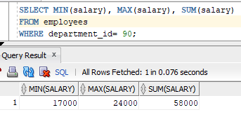

1. Find the average and total salary for each department. Round the result to 2 decimal points. (1 Mark)

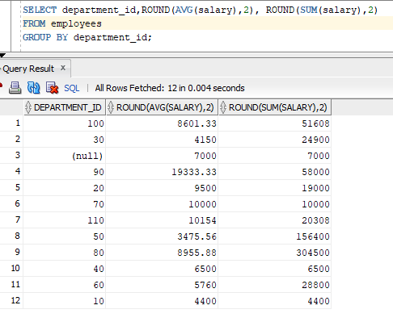

1. Find the total ST_CLERK that are hired after 2005. (1 Mark)

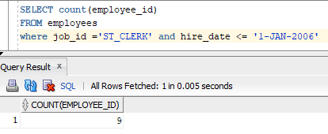

1. Find average commission received by the employees. Include the null value. (1 Mark)

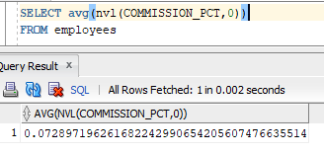

1. Find the total salary for each department. (1 Mark)

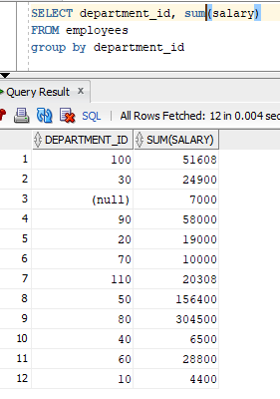

1. Find total number of employees that are hired in 2007 and 2009. (1 Mark)

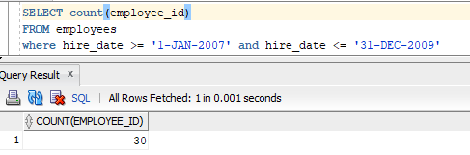

1. Find the maximum salary for job ST_CLERK and ST_MAN. (1 Mark)

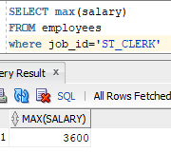

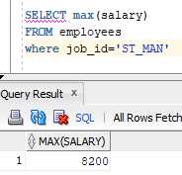

1. Find the minimum for the average salary for each department. (1 Mark)

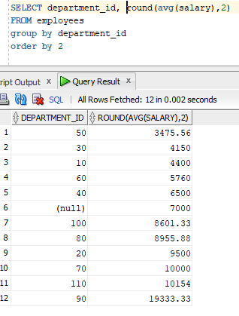

minimum salary is 3475.56

1. Find the employees that are having salary lower than the average salary. (1 mark)

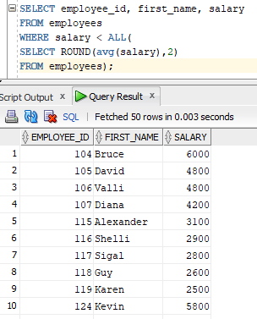

1. What is the progress of your project? (1 mark)

